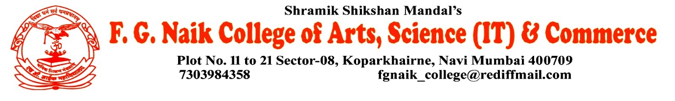

NSS UNIT
SAVITRI BAI PHULE AND RAJMATA JIJAU JAYANTI CELEBRATION
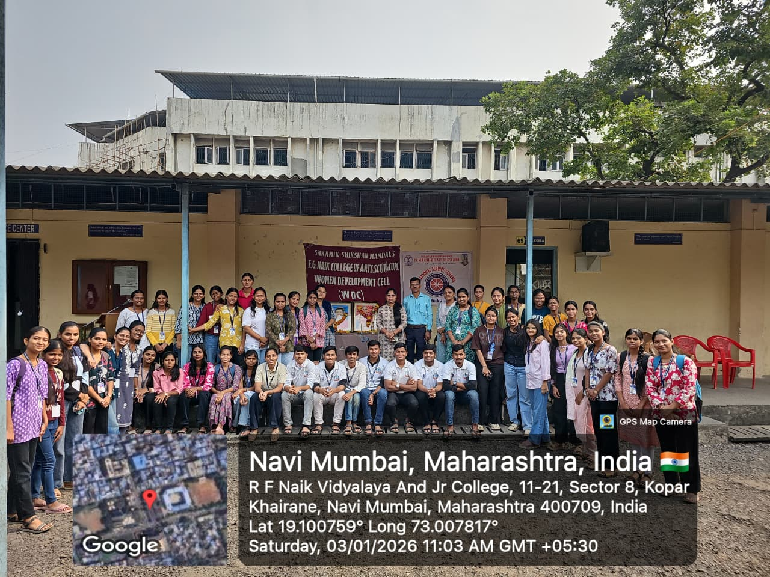

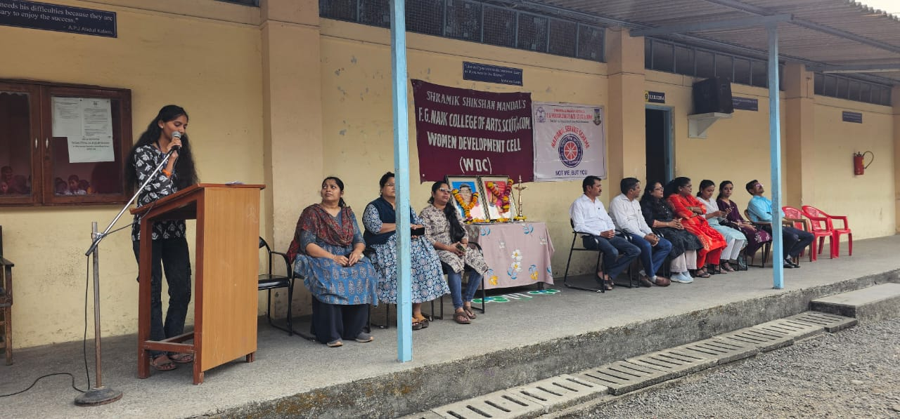
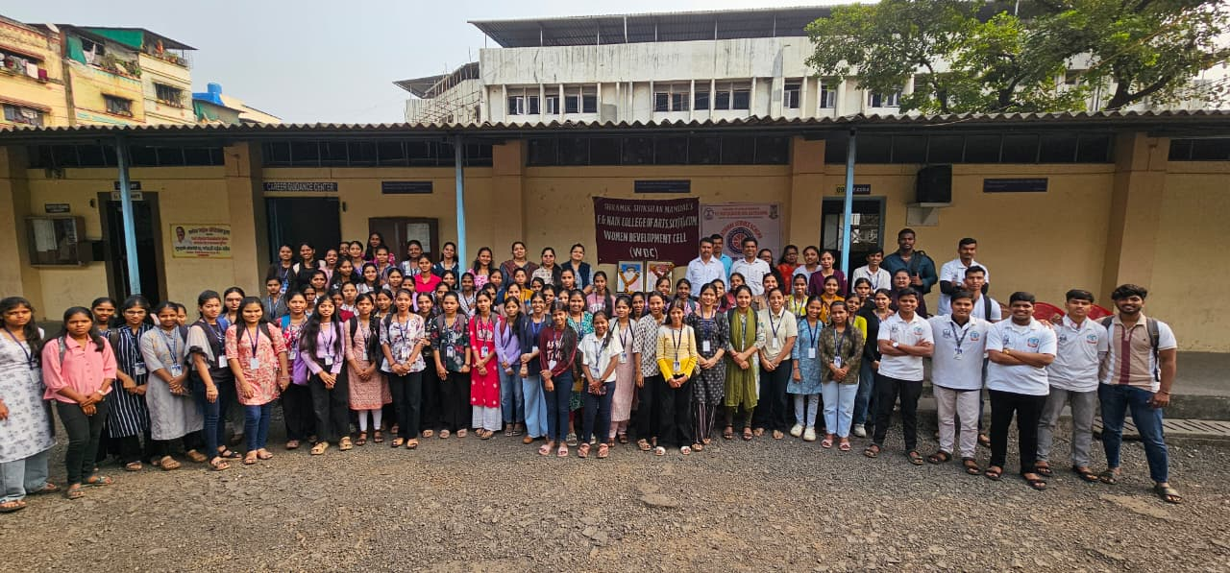

OBJECTIVE OF PROGRAM: To commemorate the birth anniversaries of Savitribai Phule and Rajmata Jijau, and to create awareness about their invaluable contributions to women empowerment, education, social reform, and nation building.
DATE: 03/01/2026
LOCATION: F.G Naik College
PARTICIPATING STAFF: All the NSS volunteers, teaching and the non-teaching staff of the college.
NUMBER OF VOLUNTEERS PARTICIPATING: 24
The NSS Unit organized the Savitribai Phule and Rajmata Jijau Jayanti Celebration to honor the legacy of two great women who played a significant role in shaping Indian society. The program highlighted Savitribai Phule’s contribution to women’s education and social equality, and Rajmata Jijau’s role in nurturing values of courage, leadership, and patriotism.
Students were made aware of the ideals and teachings of both leaders through informative discussions. The celebration inspired students to follow the principles of education, empowerment, discipline, and moral values in their lives.
PROGRAM DETAILS: The program commenced with a formal gathering, creating a respectful and inspiring atmosphere.
The NSS Unit successfully conducted the Savitribai Phule and Rajmata Jijau Jayanti Celebration, emphasizing their lasting influence on society and the importance of women’s empowerment and value-based education.

NSS IQAC
PROGRAM OFFICER CO-ORRDINATOR I/C PRINCIPAL

